# Peter’s Code: Implement “Add Town” Functionality

Peter wants to implement **new functionality** for **adding new towns**:

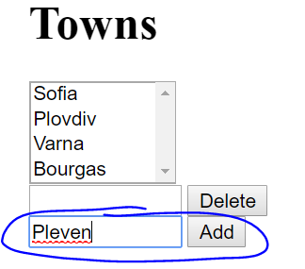 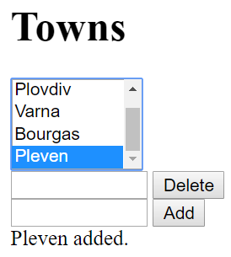

He **clones** the project repository, makes a sequence of **changes** in the source code files, **commits** locally in his repository, then **pushes** the committed changes to GitHub.

## Clone the “Towns” Repository

Peter starts by **cloning** the project repository:

|  |
| --- |
| git clone https://github.com/SoftUni/towns |

## New Town Textbox + Button

In towns.html, he adds a textbox + button for creating a new town:

|  |
| --- |
| <div>  <input type="text" id="townNameForAdd" />  <button id="btnAdd">Add</button>  </div> |

## New Town JavaScript Code

In towns.js, he adds a new function for adding a new town:

|  |
| --- |
| function addTown() {  let townName = $('#townNameForAdd').val();  $('#townNameForAdd').val('');  $('#towns').append($('<option>').text(townName));  $('#result').text(townName + " added.");  } |

Also, he adds a code to **attach an event handler** to invoke the new function when the **[Add]** button is pressed. In the start of the JS code, he adds the code marked in **bold** below:

|  |
| --- |
| $(document).ready(function() {  …  $('#btnAdd').click(addTown);  }); |

## Test the Project Functionality

Peter now **tests the project functionality** to see whether the styling and effects work correctly, as well as whether the entire project works as expected:

 

## Commit All Changes in the Local Repo

Peter **adds** and **commits** in Git all local changes:

|  |
| --- |
| git commit -a -m "Implemented functionality to add a new town" |

## Push the Local Commits to GitHub

Peter pushes all his changes to Git:

|  |
| --- |
| git push |

## Resolve Any Conflicts

In case of **conflict** Peter **pulls**, **merges**, then **pushes** again:

|  |
| --- |
| git pull |

Peter edits all files and fixes the code in order to merge all concurrent changes correctly.

Then, Peter adds and commits in Git the merged files:

|  |
| --- |
| git commit -a -m "Implemented functionality to add a new town + merged the conflicting files" |

Finally, Peter pushes all his changes again to Git:

|  |
| --- |
| git push |